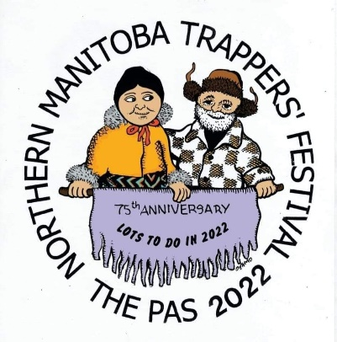
Northern Manitoba Trappers’ Festival
NEWS RELEASE

For immediate release
13 January 2022
The Northern Manitoba Trappers’ Festival would like to share with the community that we are currently in the planning stages of celebrating the 75th Anniversary of our Festival. Trappers’ Festival is scheduled for February 16th to 20th, 2022 and planning is well underway. “We are excited to be planning for Festival this year and want to assure everyone that all event planning is being done under the current provincial COVID health and safety orders,” Festival Chair Jenn Cook said. “We are looking at ways to again bring the community Trappers’ Festival in a safe way and as such we are constantly updating and revising event planning. We want our community to be able to celebrate our 75th anniversary in a way that ensures spectators and participants are safe,” Cook added.
As a result of the on-going COVID pandemic and changes to provincial orders, Trappers’ Festival is committed to ensuring that all provincial protocol requirements are met. “The COVID situation means that all planning on our part must be fluid. We will announce events in the upcoming weeks but want to remind everyone that all events are subject to change as provincial protocols change. We are working closely with government representatives to ensure we are within all provincial protocols. It is imperative for everyone to understand that events may be announced, change and in some cases even cancelled but we will work to brining our community an exciting 75th year,” Cook said.
“We are excited to continue the legacy of Trappers’ Festival and want to remind anyone looking at participating in events or attending events will be required to follow all COVID health and safety protocols including masks, capacity limits and vaccination requirements,” Cook said. “We had to modify the 2021 Festival and will do so again this year. We appreciate everyone’s support in helping us continue the legacy of Trappers’ Festival in the community. Remember there is Lots to do in 2022.”
-30-
For more information contact Jennifer Cook, General Chair 204-627-9208

